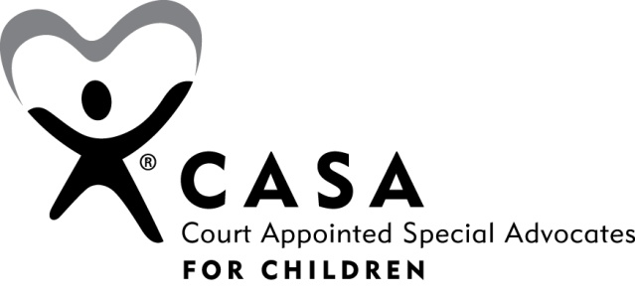

CASA Advocacy Plan Addendum for Older Youth Ages 12-21
Check that the youth’s case file has the following information:
- Documents
  - Birth Certificate
  - Social Security Card
  - Photo Identification
  - Health Card
- Ansell-Casey Life Skills Assessment
  - Date of Completion
  - Notes
- Life Skills
  - Service Provider
  - Date Begun
  - Date of Completion
- Aftercare (Must have completed life skills in order to access aftercare and wraparound funds)
  - Date of Referral
  - Service Provider
- Transition Plan
  - Date of Initiation/Update
- Plans and Services Employment
  - Current/ Most Recent Employer:
  - Resume Created
  - Strength and Weaknesses Assessment
    - Date:
    - Notes:
    - Educational and Vocational Assessment
    - Date
    - Notes:
- Housing Information and Documentation
  - Notes
- Health records and documentation
  - Doctor Office Number
  - Notes
- Educational
  - Tutoring or GED Prep Yes No
  - High School Diploma or GED Yes No
  - Date Received
  - School
  - Previous IEP’s
  - Dates
  - Notes

** Important Information for Youth Leaving Foster Care **
- Even when a case is closed, youth who were in out of home placement on or beyond their 18th birthday qualify for the Medicaid Extension for Young Adults (MEYA). To enroll the number is 888-235-4766.

- Prior to a case closing the division must have a face-to-face meeting with the youth and the youth must complete/update their transitional plan with their worker and receive a copy.

- The youth must receive/give two months notice and complete the following forms:
    - Termination of Services to Adolescent Client
    - Adolescent Case Closing Agreement
    - Adolescent Case Closing Checklist

- When a youth leaves, they are required to receive:
    - Child’s Health and Medical Examination Records
Child’s Education Record

