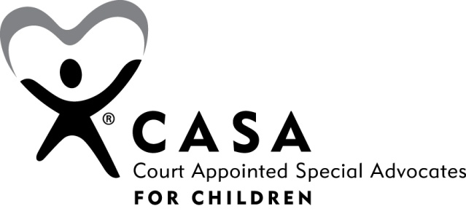
Peer Coordinator Model
The Peer Coordinator Model uses seasoned volunteers to support, coach, and supervise advocate volunteers. The model is the result of a collaborative effort between National CASA and several CASA programs. It is useful for all CASA programs – big and small, urban and rural – and is supported by National CASA.
The purpose of this model is:
- To create a fluid system of coaching and support for advocates
- To strengthen connections to the program, rather than to its people
- To expand the shared knowledge base
- To build solid relationships between all staff, paid and unpaid
- To provide a CASA for every child in care
The goal of the Peer Coordinator Model is to serve more children without having to equally increase staff and budget. It is about working smarter, not harder, and about increasing retention by building stronger relationships between all for the organization members: paid staff, unpaid staff and advocates.

