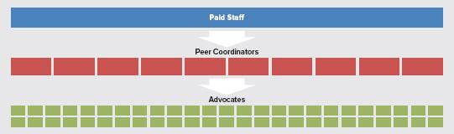

**Paid Staff**

**Peer Coordinator (PC)**

**Advocate (the CASA)**

Paid staff who manage and coach PCs

Unpaid, experienced Advocates coaching new Advocates

“Advocate” is used to distinguish the Advocate from the PC since BOTH are volunteers

Each PC coaches **5 to 10** Advocates

Advocates are directly supported by PCs and indirectly by Paid Staff. Each advocate is encouraged to take **2 cases**.

Each paid staff member manages and coaches **10 to 15** PCs